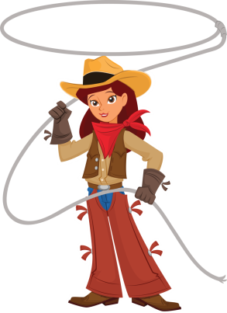
Celebrating 100 Years of Duchesne County

Duchesne County Rodeo Princess Contest Application 2015

Princess Division: Age 8-14 as of the day of the contest

Saturday, June 13,2015
10:00 am
Duchesne County Fair Grounds
Deadline to register: Wednesday June 3,2015

Mail Completed Application to:
Shawni Bowen
PO Box 115
Roosevelt, UT 84066

Questions Call:
Shawni Bowen (435)722-1806
Kerry Mather (435)724-1710

Duchesne County Rodeo Princess Contest
Saturday, June 13,2015 10:00 am
Duchesne County Fair Grounds

Princess Division: Age 8-14

Rules and Regulations
Princess: Contestants must be between the ages of 8 and 14 as of the day of the contest. They shall never have been married or pregnant. They must be a resident of Duchesne County, and they cannot be a previous Duchesne County Princess.
Princess may not hold any other Princess or Royalty titles.
If any royalty should marry or become pregnant or not fulfill her duties and responsibilities during her reign, she will forfeit her crown and all prizes won during the pageant. The title and all prizes will go to the next runner-up.
During your reign you should constantly be aware of the value of public relations between the general public and those actively involved in rodeo.

JUDGING GUIDELINES

MODELING: 1-25pts
Poise and smile (self-projection)
Choreography of pattern (difficulty of maneuver)
Eye contact with judges and audience
Balance and coordination (no wobbles on turns)
Use of stage area

SPEECH: 1-50PTS
Two – Three minute speech
Topic: 100 Years of Duchesne County
Please note: If you choose not to use this topic, you will be deducted 10 points per judge.
Credibility, presentation, and proper movement
Grammar and content
Enunciation and voice projection (manner of speaking clear)
Overall expression (smile, eye contact, remember words)

APPEARANCE: 1-25
Over all appearance. (Clothing clean, boots clean, ECT.)
Posture and fitness (overall impression)
Presentation of smile and poise (thru entire contest)
Presentation of excellence (hair, use of makeup)
Clothing style and fashion (long sleeved western dress or western skirt outfit is preferred but long sleeve western blouse and western jeans will be allowed)
Cowboy hat, western boots, belt and belt buckle are required

IMPROMPTU: 1-25
Composure, confidence and reaction
Answer applicability to topic (knowledge humor, and compassion)
Grammar
Ability to handle one’s self in a professional manner
Presentation (development and closure)
Contestants will be isolated during the impromptu. ALL CONTESTANTS WILL BE ASKED THE SAME QUESTION. Contestants will not be allowed to leave the isolated area until it is their turn to compete and no one will be allowed to contact the isolated contestants.

PERSONAL INTERVIEW: 1-50
Questions may not include topics of religion or sex
Impression of interviewer (self-projection, presentation)
Clarity and confidence
Knowledge of subjects.(Current events, animal husbandry, rodeo, etc.)
Personality (includes character, charm, sincerity; etc)
Interviews will be conducted in a private area. Only the contestant and judges in attendance. Judges ask each contestant the same questions.
Interview should be between 5-10 min. Each contestant is allowed the same amount of time.

HORSEMANSHIP: 1-50
Horsemanship patterns should not be altered in any way.
There will be only one go around of horsemanship.
Things to look for:
Hands, feet and seat
Riders balance and bounce
Hands in correct position.
Elbows should not bounce
Hand should be above and in front of horn
Straight line from her shoulder, to hip, to her toe.
Heels down, not flat or up.
Over-all look and confidence ;
1. Horse’s appearance-cleanliness, grooming. etc
2. Contestant cleanliness
3. Hat and Boot cleanliness.

Pattern #12 NRHA.com patterns
(attached)
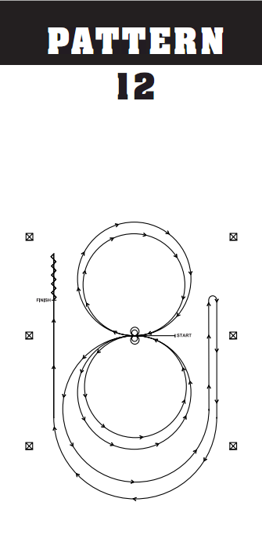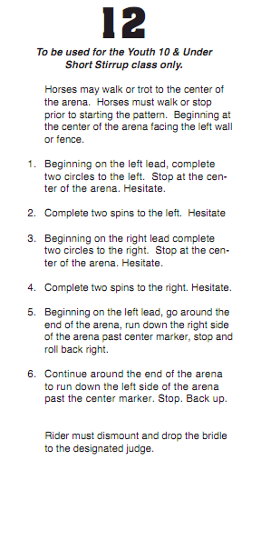

Saturday, June 13,2015
10:00 am
Duchesne County Fair Grounds

Princess Entry Form
Deadline to register: Wednesday June 3,2015
Mail to: Shawni Bowen PO Box 115 Roosevelt, UT 84066

Name:__________________________________________

Address:_________________________________________________________________

Phone:________________________________ Email:_____________________________

Age:_________ Date of Birth:_______________________

Parents/Guardians:__________________________________

Princess Contestant Contract
Miss Duchesne County Rodeo Princess symbolizes the youth of our county. She promotes the sport of rodeo and our western heritage by traveling throughout the county of Duchesne during her reign representing Duchesne County and the sport of Rodeo.
Requirements
• Live in Duchesne County during your reign.
• Be an upstanding citizen.
• Princess will need to be available for all of fair week. Events to be attended will be outlined at coronation. FULL western attire during the performances is required (including banner, belt buckle and crown). No exceptions!!!
Be available for other promotions, and charity events, throughout the year (i.e. UBIC Parade, Altamont Parade & Rodeo, Tabiona Parade and Rodeo, Dinosaur Round-Up Rodeo, Neola Events).

I, have read the above requirements and expectations of the Miss Duchesne County Rodeo Princess Contract and agree to them in their entirety.

Contestant Signature______________________________________ Date ________________

Parents/Guardians________________________________________ Date ________________

Parents/Guardians name (please print_____________________________________________________

