Duchesne County Fair 2015 Stock Rules

NOTHING other than what is listed below is allowed.
Follow general preparation and inspection on standard car rules.

No 73 or older Imperials, Lebarons, Ambulances, Hearses, Sedagons, or Limousines allowed.

1. CAGES & DOOR BARS: SEE Diagram
1. A Single bar 4pt cage system only may be used. No double bars with the exception of the driver’s door.
2. You may use channel or tubing/pipe up to 6" O.D. for Dash & Rear Seat bars. Side bars can be up to 10” tall x 6” wide channel or tubing. All bars must be straight.
3. Seat bar must be no further than 8" behind the seat.
4. Side door bars may not go past the front dash bar.
5. Interior door bars may not be more than 14” behind the seat.
6. Dash bar must be a minimum of 6” away from the center of the firewall.
7. End plates are mandatory with a max of 10”x10”, up to 3/8” thick.
8. You may add 2 VERTICAL down bars on the rear seat bar only, welded to your door bar and to the floor sheet metal. These bars may not attach to or conceal a body mount.
9. No kickers, angled or otherwise. NO cage components may be welded to the frame.
10. All cage components must be a minimum of 6" off of any floor pan sheet metal or body mount elevation, and 4” off of tranny tunnel sheet metal.
11. All cage components must be in the interior of the car, not inside the door structure with the exception of the driver’s side. The driver’s door bar MAY be inside the door structure or on the outside of the driver’s door only to allow more room for driver’s safety.
12. Driver’s door you may weld a plate Maximum 10" wide across the door for protection, not to exceed 6" beyond the exterior drivers door seams. These plates must be in the center of the door and run horizontally.

2. HALO OR ROLLOVER BARS:
1. You MUST add a halo bar or an upright post to the cage components listed above. It may not exceed 4" O.D. The cross bar must bolt to the roof in two locations.
2. Halo bars must be in a direct vertical line with the seat bar. They must be vertical.
3. Upright post must have a max 10”x10” plate attached to the roof, welded or bolted in.
4. Upright post must be mounted vertically and in such away it will not bend. (Ex. Gusseted)
5. No tranny cooler or fuel tank protectors.

3. DOORS:
1. Door seams must be welded using rolled rod no bigger than ½” or flat strap no bigger than 2” wide by 1/4” thick.
2. You may smash the inner and outer skin together of the window opening and weld them solid. You may use the same filler as in welding the door seems but no longer than the window opening per door.
3. Driver’s door and driver’s side of front windshield may have window fabric netting or chicken wire type material for driver’s safety. NO other windows may have netting.

4. BUMPERS: The intention of this rule is to allow you to mount the bumpers in such a way that they are less likely to fall off. Upon inspection if it is determined that you have exceeded the intention of the rule you will be given the opportunity to correct it in order to compete, if you are not willing to correct it you will be disqualified. Officials have final say.
1. No loaded bumpers may be used.
2. Bumper swaps are allowed.
3. Stock O.E.M. bumpers off of passenger cars may be used
4. A Maximum 5” by 5” by Maximum 3/16” SQUARE tube may be used, but must be open ended and straight. They cannot extend more than 10” from the outside of the frame. No skinning or additional metal may be added to the tube except small plates to mount if needed.
5. Bumpers may be flipped.
6. Bumpers may be cut so they do not smash into the tires during the event.
7. No chrome may be welded to the body if using compression style bumpers.
8. Chrome of bumpers may be welded to the inner beam of the compression bumper only. No additional material may be added.
9. Non compression bumpers may be welded to no more than 12 inches on the outside body only. Note: Hood must be able to open.
10. Chain may be wrapped around the bumper to the frame (one wrap per side, see hood bolting rule).

If you ARE NOT swapping bumpers,

1. Stock bumper brackets and tubes in stock locations may be welded to the front 4” of the frame only. No swapping bumper brackets and or tubes/beams.
2. On cars equipped with factory compression style bumpers you may compress the bumper shock tubes and weld them back
3. Bumpers may be welded to shock tube mounting plate or you must remove all original mounting hardware and use one 4” long x 4” tall X 1/4” thick piece of angle iron per frame rail only (see bumper swapping rule #1 below)

If you ARE swapping bumpers,

1. If swapping the bumper’s on a factory equipped compression bumper car you must use ether the stock mounting brackets and tubes in stock location’s or you must remove all original mounting hardware and use one 4” long x 4” tall x 1/4” thick piece of angle iron per frame rail welded to the outside front 4” of the frame only. No swapping brackets and or tubes/beams.
2. If adding a compression bumper to a non compression bumper car the only way it may be attached is by removing all original mounting hardware and using one 4” long x 4” tall x 1/4” thick piece of angle iron per frame rail welded to the outside front 4”of the frame only.

5. FRAME:
1. All body mounts (rubber biscuit and cone) and “Pucks” must be in place. You may not remove bolts and place washers on both sides.
2. No Buffing, grinding or packing of frames
3. No Chrysler sub-frame chaining.
4. No imperial sub-frame swaps allowed.
5. Frames may be notched.
6. Absolutely no cutting, bending or altering the front frame in any way.

6. HOOD AND TRUNK: NO BOLTING OR CHAINING THROUGH FRAME!
1. Hinge spring must be removed.
2. Trunk Lid and Hood must be 100% in stock location and open for inspection or have a 30” x 30” hole for inspection.
3. All decking in wagons must be removed.
4. Body may be pinched. Trunk may be tucked or v’d but NO wedging. Your trunk lid if V’d in the center must be at least 12 inches off trunk floor body mount elevation.
5. A combination of the following four ways to secure the hood and trunk is allowed
a. Chains or cables may be used to secure the hood and trunk
i. Chain and cable may be no larger than 3/8”. If excessive chain or cable is found, it will be cut. If using chain or cable it must be singled looped. It may go around the bumper. And it may be located anywhere on the hood or trunk.
b. If welding the hood you may use 6” inch lengths of maximum ½” rod welded in the seam.
c. Two 6 inch lengths of 2” x 2”angle iron may be welded to the body only back to back and bolted together with a ½” bolt. These cannot be welded across the seam.
d. If bolting, the hood and trunk bolts may be no larger than 8”x ¾” with two 5” washers per bolt.
6. You may mix and match the types of hood/trunk fastening, but only 2 fastening points per side of the hood/trunk may be used.
7. You are allowed to use 2 chains (3/8” chain) or 2 straps welded from hood/trunk lid to bumper no longer than 36” long by 2” wide by ¾” thick. The purpose for allowing this is to keep bummers on, no extra strengthen allowed. If we see you are exceeding this rule, you will be asked to cut it off.

7. ENGINES & REAR ENDS:
1. Engines may be swapped but must remain close to original position as possible. No cutting of the fire wall to accommodate different motors. A hole may be cut for the distributor. Motor mounts may be fastened with only one strap or chain per side to the top of the factory engine cradle. No welding to the frame.
2. If using an engine saddle or lower cradle it may only be fastened to the frame engine cradle and not the frame and you may not use any strap or chain.
3. NON trussed factory rear ends must be used. Ford in Ford, GM in GM, etc. No hybrids.
4. No transmission coolers allowed.
5. Rear end gears/axles may be changed, welded, or posi’d.
6. No Distributor /pulley protectors slip shaft drivelines, after market steering columns, or protectors of any kind may be used. No aftermarket parts of this nature at all.
7. Floor shifters allowed,

8. SUSPENSION:
1. Suspension must be stock components and working.
2. Coil springs may be welded to the axle only.
3. No other means other than tires and springs and spring spacers may be used to raise the cars suspension.
4. No adding or modifying original leaf spring clamps.
5. No leaf clamps other than factory allowed.

9. WINDOWS:
1. You must have a least one front window bars (limit two) or 3/8” chain. No rear window bars are allowed.
2. Bars may not be bigger than 36” long by 2” x 2”.
3. Bars may only be attached by welding directly to the sheet metal or with a mounting plate no bigger than 4” x 4” by 3/16” angle or plate on the roof, cowl, speaker deck or trunk. Plate cannot be mounted on the trunk lid itself.
4. Bars must be spaced at least 18 inches apart on the bottom, and no cross connections. No other added metal or mount plates.
5. If using rear window bars in a Station Wagon tailgate windows are treated as a rear window, but must be mounted at the top of the tailgate, and the tailgate must be in original closed position.
6. No wiring or chaining of any window openings.
7. Window bars may not be attached to the halo bar or any cage components.

10. RADIATORS, RADIATOR SUPPORTS: NO ALL THREAD THROUGH CORE SUPPORT, IT MUST REMAIN FACTORY!
1. Only OEM style passenger car radiators may be used. Aluminum racing radiators of the same style may be used.
2. Radiator must be attached to the core support.
3. Radiators may be mounted in such a way to hold the radiator in place, not strengthen the core support. No added metal may be used to mount the radiator. If welding radiator in place you may use four 1” welds, one per corner.
4. You may not add cooling capacity. No supplemental cooling devices allowed (electric fans are allowed).
5. If the arena allows, engine coolants may be used. Call promoter for approval.
6. Radiator loops may be used
7. Radiator supports must remain in the stock location.
8. Radiator core support seam welding is NOT allowed.
9. Radiator supports may not be welded to the frame, bumper brackets, bumpers or anything else.
10. If using a condenser to protect the radiator, it may be tie wired to the core support only.

11. FUEL DELIVERY SYSTEMS:
1. Metal Marine type tank, metal fuel tank or derby type metal fuel tank is required.
2. 6 gallon max tank maximum may be used.
3. Original gas tanks must be removed from the car.
4. You must have the gas tank securely mounted behind the driver’s seat with bolts, metal straps, or chain. No seat belts or pull tie straps may be used.
5. Fuel lines must run inside the car, not under the car along the frame. Fuel line must be inside a protective line with in the engine compartment.

***IF USING AN ELECTRIC FUEL PUMP, YOU MUST BRING IT TO INSPECTORS ATTENTION AT TECH***

1. Electric fuel pumps are allowed. The on/off switch must be easily accessible and clearly marked with bright paint. An “E” will be attached rear pillar during Tech to Identify the Electric Fuel Pump.
2. Automotive pump gas only, NO ALCOHOL TYPE FUEL MAY BE USED!

12. BATTERIES:
1. Only one battery of any type may be used.
2. They must be secured inside the car and covered, unless you are using a gel cell battery
3. Battery box must be made out of metal! It must be bolted to the floor. Bolts may not go thru or around the frame. Seat belts or pull type tie downs may not be used.
4. Rusted out holes in your floor sheet metal may be patched where components will be mounted or for drivers safety with sheet metal only. You may not patch clean and solid floors.
5. All body mounts must be visible.

13. TIRES & BRAKES:
1. No split rims, studded tires, or Duals
2. Stock Rims only, no bead locks or reinforcing of the rim is allowed.
3. Valve stem protectors allowed. Wheel weights must be removed.
4. All cars must be able to demonstrate the ability to stop at any time. If your brakes do not work, you will not compete.
5. You may not change tires after inspection without officials consent.

14. AIR CLEANERS:
1. You must have an air cleaner over the carburetor all at times during the event.
2. There must be an opening cut in the hood on each side of the air cleaner for fire suppression. Minimum of 12 inch diameter.

15. CUT OUTS:
1. Cut outs over the wheel wells are legal.
2. No welding or bolting of the cutouts is allowed.
3. If inspection holes and fire holes are determined to be too small you will be asked to cut them larger.
4. Anything can be removed; NOTHING can be added.

OVERALL SAFETY IS OUR GOAL AND WILL BE DETERMINED BY THE TRACK OFFICIALS!

Sample Cage Layout

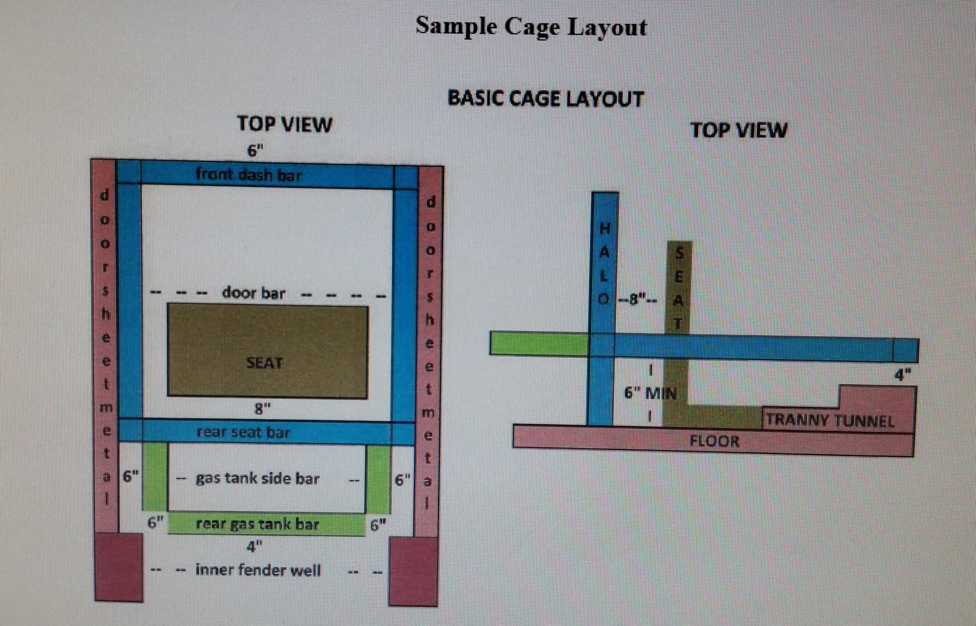

*No fuel protector for stock class (see rules)

