Magic is in the air at the Duchesne County Fair

2017 Duchesne County Fair Rodeo Queen Contest Application

Queen Division: Age 15-24 as of the day of the contest

Saturday, June 10th
10:00 am
Duchesne County Centennial Event Center

Mail Completed Application to:
Shawni Bowen
PO Box 115
Roosevelt, UT 84066

Questions Call:
Shawni Bowen (435)722-1806
Kerry Mather (435)724-1710

Duchesne County Fair Rodeo Queen Contest
Saturday, June 10th
10:00 am
Duchesne County Centennial Event Center

Queen Division: Age 15-24

Rules and Regulations
Queen: Contestants must be between the ages of 15 and 24 as of August 1st. They shall never have been married or pregnant. They must be a resident of Duchesne County, and they cannot be a previous Duchesne County Queen.
Queen may not hold any other Queen or Royalty titles.
If any royalty should marry or become pregnant or not fulfill her duties and responsibilities during her reign, she will forfeit her crown and all prizes won during the pageant. The title and all prizes will go to the next runner-up.
During your reign you should constantly be aware of the value of public relations between the general public and those actively involved in rodeo.

JUDGING GUIDELINES

MODELING: 1-25 points
Poise and smile (self-projection)
Choreography of pattern (difficulty of maneuver)
Eye contact with judges and audience
Balance and coordination (no wobbles on turns)
Use of stage area

SPEECH: 1-50 points
Two – Three minute speech
Topic: Duchesne County and the MAGIC within
Please note: If you choose not to use this topic, you will be deducted 10 points per judge.
Credibility, presentation, and proper movement
Grammar and content
Enunciation and voice projection (manner of speaking clear)
Overall expression (smile, eye contact, remember words)

APPEARANCE: 1-25 points
Over all appearance. (Clothing clean, boots clean, ECT.)
Posture and fitness (overall impression)
Presentation of smile and poise (thru entire contest)
Presentation of excellence (hair, use of makeup)
Clothing style and fashion (long sleeved western dress or western skirt outfit is preferred but long sleeve western blouse and western jeans will be allowed)
Cowboy hat, western boots, belt and belt buckle are required

IMPROMPTU: 1-25 points
Composure, confidence and reaction
Answer applicability to topic (knowledge humor, and compassion)
Grammar
Ability to handle one’s self in a professional manner
Presentation (development and closure)
Contestants will be isolated during the impromptu. ALL CONTESTANTS WILL BE ASKED THE SAME QUESTION. Contestants will not be allowed to leave the isolated area until it is their turn to compete and no one will be allowed to contact the isolated contestants.

PERSONAL INTERVIEW: 1-50 points
Questions may not include topics of religion or sex
Impression of interviewer (self-projection, presentation)
Clarity and confidence
Knowledge of subjects.(Current events, animal husbandry, rodeo, etc.)
Personality (includes character, charm, sincerity; etc)
Interviews will be conducted in a private area. Only the contestant and judges in attendance. Judges ask each contestant the same questions.
Interview should be between 5-10 min. Each contestant is allowed the same amount of time.

HORSEMANSHIP: 1-50 points
Horsemanship patterns should not be altered in any way.
There will be only one go around of horsemanship.
Things to look for:
Hands, feet and seat
Riders balance and bounce
Hands in correct position.
Elbows should not bounce
Hand should be above and in front of horn
Straight line from her shoulder, to hip, to her toe.
Heels down, not flat or up.
Over-all look and confidence ;
1. Horse’s appearance-cleanliness, grooming. etc
2. Contestant cleanliness
3. Hat and Boot cleanliness.

Queens will be required to mount at beginning of pattern and dismount at completion of pattern for judges.
Pattern #9 NRHA.com patterns
(attached)
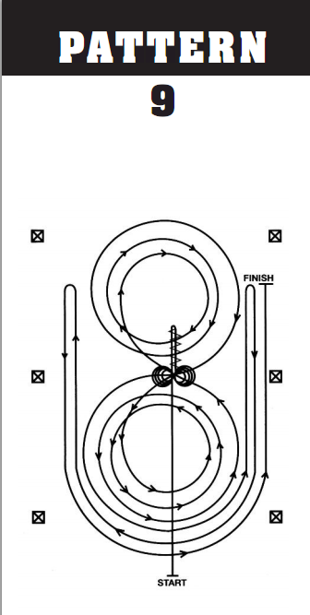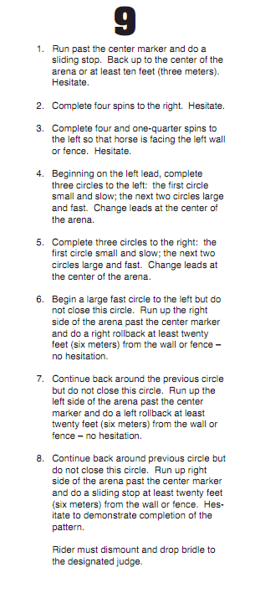

Saturday, June 10th
10:00 am
Duchesne County Centennial Event Center

Queen Entry Form
Deadline to register: Saturday, June 3rd
Mail to: Shawni Bowen PO Box 115 Roosevelt, UT 84066

Name:__________________________________________

Address:_________________________________________________________________

Phone:________________________________ Email:_____________________________

Age:_________ Date of Birth:_______________________

Parents/Guardians:__________________________________

Queen Contestant Contract
Miss Duchesne County Rodeo Queen symbolizes the youth of our county. She promotes the sport of rodeo and our western heritage by traveling throughout the county of Duchesne during her reign representing Duchesne County and the sport of Rodeo.
Requirements
• Live in Duchesne County during your reign.
• Be an upstanding citizen.
• Queens will attend all Duchesne County Fair performances. FULL western attire during the performances is required (including banner, belt buckle and crown). No exceptions!!!
Be available for other promotions, and charity events, throughout the year (i.e. UBIC Parade, Altamont Parade & Rodeo, Tabiona Parade and Rodeo, Dinosaur Round-Up Rodeo, Neola Events).
• Attend no less than three rodeos to promote the Duchesne County Rodeo/Fair. No Exceptions!

I, have read the above requirements and expectations of the Miss Duchesne County Rodeo Queen Contract and agree to them in their entirety.

Contestant Signature______________________________________ Date ________________

Parents/Guardians________________________________________ Date ________________

Parents/Guardians name (please print_____________________________________________________

